FYQ Typeform — Pipedrive Lead Processing Automation

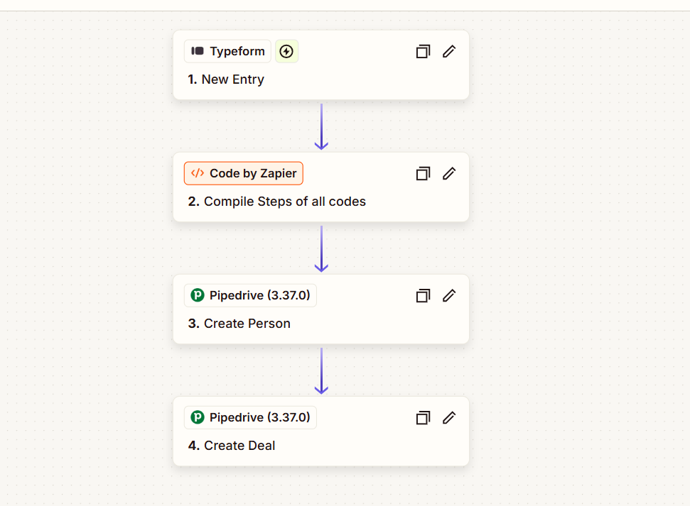

Project Description
An end-to-end lead-processing automation built to take FYQ submissions from Typeform and move the information through the different systems automatically. The workflow processes the responses, organizes the data in Airtable, creates the relevant contact and deal in Pipedrive, and triggers an email once the lead has been processed.
Instead of manually reviewing and transferring information between platforms, the automation handles the data flow from the initial submission through CRM entry and communication.

Automation Scope
- Typeform new-entry trigger
- FYQ outcome data processing
- Study-challenge response processing
- Code-based data transformation
- Airtable record creation
- Final data compilation and formatting
- Pipedrive person creation
- Pipedrive deal creation
- Automated Gmail email
- Cross-platform lead synchronization
- Automated lead data management

Workflow
Typeform New Entry → Code by Zapier: Split FYQ Outcomes → Code by Zapier: Split Study Challenges → Airtable: Create Record → Code by Zapier: Complete Processing → Pipedrive: Create Person → Pipedrive: Create Deal → Gmail: Send Email
The workflow starts with a new FYQ Typeform submission and processes the responses through multiple Code by Zapier steps to organize the outcome and challenge data. The structured information is then saved to Airtable before being passed into Pipedrive, where the person and associated deal are created. Once the lead reaches the CRM, Gmail sends the required follow-up communication.

Key Objective
Automate the full FYQ lead journey from submission to CRM and communication, keeping lead information organized across Airtable and Pipedrive while removing repetitive manual data entry and ensuring each new submission is processed consistently.

